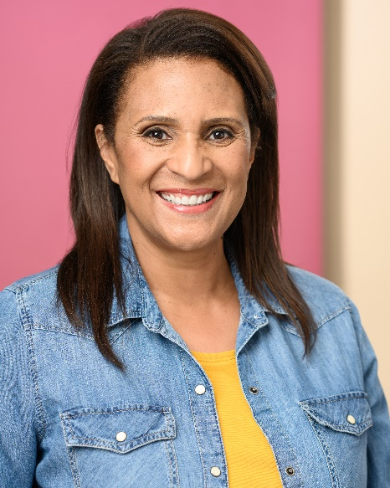
Jennifer Batson White
Actor | Model

Represented by STARS The Agency
LA: 323-962-1800 x 120
SF:415-421-6272 x 120
Location: Los Angeles, CA

Height: 168.91 cm/ 5’7"

Build: Curvy Athletic

Eyes: Brown
Hair: Brown
Gender: Female
Ethnicity: African American | Ethnically Ambiguous

www.JenniferBatsonWhite.com
FILM

San Francisco Jewish Film Festival | Role: Principal | Director: Brian Perkins
Short Film | Role: Lucinda | Director: Casey Lee
The Bright Side of Being Barren | Role: Party Goer | Director: Tony Gapastione
Ballet Film | Role: Principal | Heather Lynn Casting
Q An American Secret | Role: Featured | Director: Curt Tanner
THEATRE
The Dawson Sisters | Role: Annette | Director: Casey Lee

COMMERCIAL
Verily | Role: Principal | Director: Lauren O’Halloran

EDUCATION & TRAINING

CL Actors Lab  2020 – present | Scene Study, On Camera, Improv, Cold Reading, Audition | Instructor: Casey Lee  Hollywood, CA
Los Angeles Tribe Workshop  2021 | Scene Study, On Camera, Improv, Cold Reading, Audition | Instructors: Ski-ter Jones & Southpaw Casting Studios  Los Angeles, CA
Bad Aunties Improv Workshop |  | Instructors: Diane Amos,  Judy Nihei, Debi Durst  Berkeley, CA
How to Fail Brilliantly:  Improv & Clown Workshop |  | Instructor: Joshua Han  Los Angeles, CA
Plan to Action Workshop:  The Actor's Business | Building a personal brand, marketing your business, and identifying your type. | Instructor: Aya Hoja  Berkeley, CA
Berkeley Improv Workshop |  | Instructor: Rashaad Leggett  Berkeley, CA
B.S. in Physical Education | University of Illinois - Chicago

SKILLS
Tennis, Swimming, Skiing, Table Tennis, Badminton, Piano, Dance: Ballet, Jazz, Volleyball, Softball, Jumping Rope, Fishing, Golf, Cooking.

